**Mr SGs Chemistry ATAR Unit 3 Course Summary**

**Equilibrium Systems**

**Collision theory:** For a chemical reaction to occur, the following needs to happen

-Reactant particles need to collide

-In the correct orientation

-With enough kinetic energy to overcome the EA barrier

-All factors affecting the rate of a reaction (or the balance of an equilibrium) can be explained by their effect on the rate of collisions or the proportion of collisions where Ek > EA

Factors ↑ rate of collisions: ↑ P, ↓ V, ↑ conc/ pp, ↑ T, ↑ state of subdivison

Factors ↑ proportion of successful collisions: ↑ temp, catalyst

A system is at equilibrium when:

-Rates of forward and reverse reactions are equal

-Concentrations of all reactants and products are constant

-Macroscopic properties of the system are constant

-**Le Chatelier’s Principle** (LCP) can be used to predict how a system will respond to an applied change

If a system at equilibrium is subjected to a change in conditions it will act to partially counteract the change

**-Equilibrium Constant (K)/ Reaction Quotient (Q)**

For the reaction aA + bB 🡨🡪 cC + dD, K = [C]c[D]d

[A]a[B]b

-The expression represents K at equilibrium and Q when not at equilibrium

-K is constant for a system at equilibrium for a particular temperature

-Only changes in the concentration of a gas or aqueous substance can alter the value of Q

-Only a change in temperature can alter the numerical value of K

**Changes to equilibrium**

To determine (or to graph) how a system will respond to an applied change:

-Determine whether the applied change will cause an immediate change in any concentrations

-Use LCP to predict how the system can partially counteract the change

-Determine whether the forward or reverse reaction will be temporarily favoured in order to partially counteract the change

-If asked to explain the change, use collision theory to explain why the rates of the forward and reverse reactions change

- The forward and reverse reaction rates will then converge until equilibrium is re-established

-As the system moves towards the new equilibrium, the concentrations of substances will change in proportion with their coefficients

**Rate and Equilibria considerations in industry**

-**Rate** (how quickly the reaction reaches equilibrium) can be maximised by using high temperatures and pressures and an appropriate catalyst

-**Yield** can be maximised by using a pressure and temperature that favours the forwards reaction, constantly removing products and adding at least one (preferably cheap) reactant in excess

-**Cost** can be minimised by using low temperatures and pressures

**Equilibria involving atmospheric and oceanic CO2**

-↑ atmospheric CO2 concentrations result in acidification due to reactions 1-3

-↑ acidity (↑ [H3O+]) causes ↓ [CO32-] by shifting equilibrium 5 to the left

-Equilibrium 5 also acts to buffer pH in human blood

1) CO2(g)🡨🡪 CO2(aq)

2) CO2(aq)+H2O(l) 🡨🡪 H2CO3(aq)

3) H2CO3(aq) +H2O(l) 🡨🡪 HCO3-(aq) + H3O+(aq)

4) H2CO3(aq) +H2O(l) 🡨🡪 HCO3-(aq) + H3O+(aq)

5) HCO3-(aq) +H2O(l) 🡨🡪 CO32-(aq) + H3O+(aq)

**Acids and Bases**

-The Bronsted Lowry theory defines acids as proton donors and bases as proton acceptors

**Acidity Constants (KA)**

-For the reaction: HA + H2O 🡨🡪 A- + H3O+ KA = [A-][H3O+]

[HA]

-As acid strength is determined by the degree of ionisation, it can be measured with KA

**Acidity/Basicity of Salts**

-Salts will be acidic or basic, if they can react with water in a hydrolysis reaction to produce H3O+ or OH- ions

|  |  |  |
| --- | --- | --- |
| **Acidic** | **Basic** | **Neutral** |
| Conjugate acids of weak bases | Conjugate bases of weak acids | Conjugate bases of strong monoprotic acids |
| Transition metal ions | HCO3- , CO32-, HPO42-, PO43- | Conjugate acids of strong bases |
| HSO4-, H2PO4- |

**Buffers**

-Buffers are solutions that contain a weak acid (HA) and it’s conjugate base (A-)

-They resist changes in pH by undergoing the following reactions:

H3O+ + A- 🡪 HA + H2O (can resist addition of acid, until all A- 🡪 HA)

OH- + HA 🡪 A- + H2O (can resist addition of base, until all HA 🡪 A-)

**pH**

-Water self ionises according to: H2O + H2O 🡨🡪 H3O+ + OH-

Kw = [H3O+][OH-] = 1.0 x 1014 at 25°C pH = -log[H3O+] [H3O+] = 10-pH

**Indicators**

-Indicators are weak acids where the acid (HInd) and its conjugate base (Ind-) are different colours

-Changes in pH change their colour, by altering the equilibrium

HInd + H2O 🡨🡪 Ind- + H3O+

-Indicators will change colour close to their pKa(the pH at which [HInd] = [Ind-])

- pKa = -log10Ka

**Volumetric Analysis (titrations)**

-In an acid base titration, an acid/base of unknown concentration has its concentration determined by measuring the volume of a standard solution required to react with it

**-Standard solutions** are those with a known concentration

**-Primary Standards** have the following characteristics:

-Known formula, high purity, chemically stable (not deliquescent or hygroscopic), high formula mass

-Common primary standards include anhydrous sodium carbonate and oxalic acid

**-Secondary Standards** have their concentration measured by titration against a primary standard

|  |  |
| --- | --- |
| **Equipment** | **Rinsed with….** |
| Burette | Solution it will be filled with |
| Pipette | Solution it will be filled with |
| Conical Flask | Water |

-The progress of the reaction is usually measured by using an indicator that changes colour during the large pH change associated with the completion of the reaction

**Equivalence point:** The point at which stoichiometric quantities of reactants have been added

**End point:** The point at which the indicator will change colour

-An indicator is suitable for a titration if its end point occurs at the equivalence point (eg if its pKa ≈ pH at equivalence point)

|  |  |  |  |
| --- | --- | --- | --- |
| **Acid** | **Base** | **pH at equivalence point** | **Suitable indicators** |
| Strong | Strong | ~7 | methyl orange, phenylphthalein |
| Strong | Weak | <7 | methyl orange |
| Weak | Strong | >7 | phenylphthalein |
| Weak | Weak | ~7 | pH meter only |

-Calculations from a titration are made based on concordant titres only (those within 0.1 mL)

**Redox**

**-**At the **AN**ode, **O**xidation **I**s **L**oss of electrons, **R**eduction **I**s **G**ain of electrons at the **CAT**hode (AN OIL RIG CAT)

-Oxidation can also be defined as an increase in oxidation number and reduction as a decrease in oxidation number

**Determining oxidation number (O.N.)**:

-elements have an O.N. of O

-monoatomic ions have an O.N. equal to their charge

-oxygen has an O.N. of -2 in compounds, except in F2O (+2) and peroxides (-1)

-hydrogen has an O.N, of +1 in compounds except metal hydrides (-1)

-the sum of oxidation numbers in a compound/polyatomic ion is equal to its charge

**Writing redox half equations:**

1. determine the substances being oxidised and reduced, using oxidation numbers
2. write down the oxidant or reductant and its product
3. balance the atoms undergoing oxidation or reduction
4. balance the oxygen atoms by adding water to one side
5. balance the hydrogen atoms by adding hydrogen ions to one side (acidic conditions)
6. balance charges by adding electrons
7. add state symbols

**Combining half equations into a redox equation**

1. multiply both half equations by a coefficient so that they contain the same number of electrons
2. combine the equations by writing all reactants from both half equations on the left and all products from both half equations on the right
3. simplify by cancelling out electrons and substances that appear on both sides of the equation

**-**The **Electromotive force** (emf) of a redox reaction can be used to determine the voltage of a cell, or whether a reaction will occur spontaneously (eg if E°cell > 0)

E°cell = E°oxidation + E°reduction

**Galvanic (electrochemical) cells** convert chemical potential energy into electrical energy

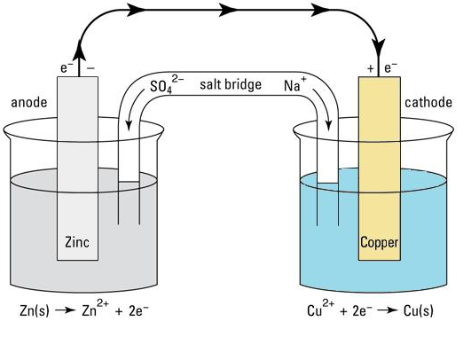

Anode: site of the oxidation half reaction, negative terminal of the cell

External circuit: allows electrons to flow from anode to cathode, performing work

Cathode: site of reduction half equation, positive terminal

Electrolyte: Allows current to flow from cathode to anode as ions (cations to cathode, anions to anode)

Salt Bridge: Contains unreactive, highly soluble ions, allowing current to flow between half cells

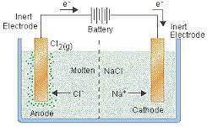**Electrolytic cells** use electrical energy to drive a non-spontaneous redox reaction

Power supply: Supplies the electrical energy required, provides electrons to cathode

Cathode: Site of reduction half equation, negative terminal of the cell

Electrolyte: Allows charge to flow from cathode to anode as ions, can contain reactants for the redox reaction

Anode: Site of oxidation half equation, positive terminal of the cell

-In **fuel cells**, the reactants must be continually added to the cell

**Calculations**

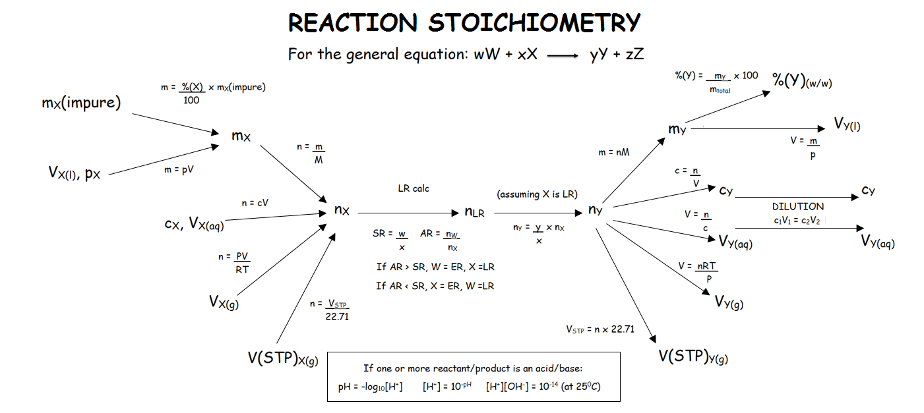

-For reactions that are not 100% efficient, m(product)actual = m(product)max x (%efficiency/100)

*NOTE: This document covers Year 12 content only. The Year 12 Syllabus assumes that you are familiar with content taught in Year 11. Year 11 content that may need to be revised include, general reaction types, ionic and molecular equations, observations, ionic charges and solubility rules*